7.1.5. Green Campus initiatives of the college.
Response:
Workshop on Écobrick & its Importance organized by NSS, Margherita College on 19.12.2020 at conference Hall on the theme protect environment by not using plastics. Resource persons were Dr. J.P. Debnath Mr. Proban gogoi & Mr. Biswajit. Teacher particpants 20 students 150.
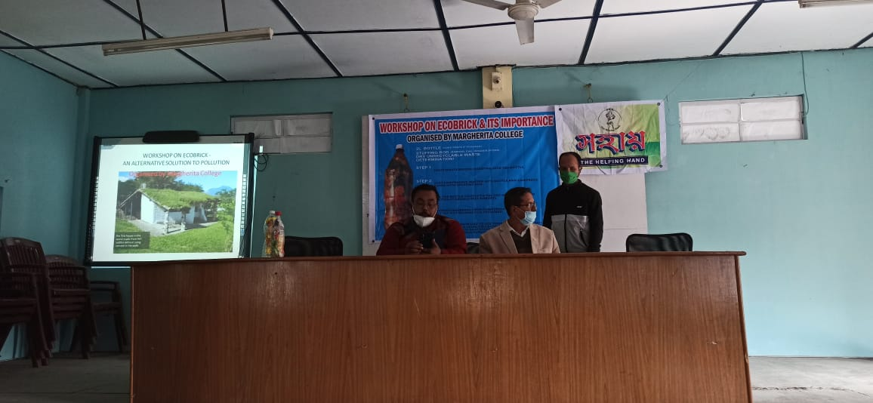

NSS initiated a Cleanliness Drive inside & outside the college campus on 17.02.21. as a regular practice. The objective of the programme was to generate a sense of responsibility among the volunteers. Participants were around 25, Teacher 03.
